REPORT ON SCHOOL-BASED CLIMATE CHANGE EDUCATION PROJECT
Activity dates: 10th – 15th November 2025 in Bumasifwa & Legenya Sub-counties, Sironko District, Uganda
Implemented by: Foundation for Sustainable Environment (FSE) in partnership with: Green Nexus Education (United Kingdom)

1. Introduction
This report details key findings, achievements, lessons learnt, challenges encountered, recommendations and conclusions during the School-based Climate Change Education project on activities conducted between 10th and 15th November 2025 across Bumasifwa and Legenya Sub-counties in Sironko District.
The Foundation for Sustainable Environment (FSE), in strategic partnership with Green Nexus Education (UK), rolled out the School Climate Education and Environmental Conservation Project, a pioneering initiative designed to empower children aged 6–16 years with essential climate change knowledge and practical environmental skills in primary schools in Sironko District.
Over this five-day period, the session was delivered virtually by Ms. Nassi, Executive Director of Green Nexus Education (UK), using child-friendly videos, interactive presentations, and real-life climate examples. This marked the official launch of FSE’s long-term commitment to nurturing climate-literate generations in Uganda’s rural schools.
The initiative reached three schools:
- 12th November 2025 – Bulwala Primary School
- 13th November 2025 – Bumasifwa Primary School
- 14th November 2025 – Bumasobo Primary School
Across all schools, the sessions sparked enthusiasm, curiosity, and active participation, proving that rural school children, when given the opportunity, are eager to understand the environmental challenges affecting their communities and ready to take action.

2. About the Foundation for Sustainable Environment (FSE)
FSE was established in 2020 by indigenous people led by women in Bunamahande community with a vision of building a community that strive towards achieving protection of environment and addressing climate change crisis in a manner that promotes equity and social justice, gender-responsive, environmental justice, sustainable livelihoods, biodiversity to protection sustainable lives focused on implementing practical hands-on community driven projects aimed at sustainable environment.
Our Vision. “A sustainable environment for present and future generations”
Mission Statement. Empowering sustainable communities to address climate change and environmental devastation through environmental stewardship, integrating native knowledge, skills and initiatives underpinned by gender equitable community -led approaches.
Values of FSE
- Integrity: we cherish transparence, honest, and ethics in all our interactions, engagement and decision-making process.
- Conservation: we prioritize protection and preservation of national resources, ecosystems and biodiversity.
- Inclusivity: we foster a culture of diversity, collaboration, equity, and social justice in pursuit of environment sustainability.
- Stewardship: we responsibly manage, protect and preserve natural resources for future generations.
- Resilience: we proactively plan, adapt to address environmental challenges and uncertainties with innovative solutions.
Objectives of FSE
- Advance Climate Change Mitigation & Adaptation
Promote sustainable, community-driven solutions that reduce greenhouse gas emissions, enhance local adaptation, and position indigenous communities as leaders in climate resilience.
- Conserve Ecosystems & Natural Resources
Protect forests, water, soil, and biodiversity through reforestation, renewable energy, waste management, and eco-friendly practices that safeguard the environment for future generations.
- Promote Gender Equity & Environmental Justice
Ensure women, girls, and marginalized groups have equitable access to resources, opportunities, and decision-making in environmental management and climate action.
- Strengthen Community Livelihoods & Green Economy
Support sustainable income-generating activities, green skills development, and eco-enterprises that balance economic empowerment with environmental stewardship.
- Leverage Indigenous Knowledge, Research & Innovation
Build local capacity by integrating traditional wisdom with research, innovation, and evidence-based approaches to design effective, context-specific environmental solutions.
- Build Resilient Communities through Advocacy & Partnerships
Enhance community resilience to environmental and climate shocks through policy advocacy, education, and strong collaborations with local, national, and international stakeholders.
FSE’s approach is rooted in local leadership, women led strategies, youth empowerment, and community ownership, ensuring that solutions are sustainable, inclusive, and impactful.

3. Purpose of the School Climate education sessions
The School Climate Education and Environmental Conservation Project was designed with the following objectives:

1. Inspire young learners to become lifelong environmental stewards. Children represent the most powerful entry point for long-term climate resilience, early empowerment increases climate-smart behaviors at household and community levels.

2. Introduce a peer-led climate model in schools. The program encourages learners to form climate clubs, take leadership roles, and champion environmental awareness among their peers.

3. Cultivate climate consciousness from an early age. Through interactive videos, audio-visual materials, and engaging discussions, the sessions build foundational understanding of climate change, adaptation, and biodiversity.

4. Strengthen partnerships with school community for climate action and adaption. The model ensures that teachers, school leaders, and local government structures participate actively in nurturing climate-responsive schools.

5. Establish youth-led climate and environment clubs. These clubs will sustain continuous environmental learning, tree planting, waste management, hygiene and sanitation, climate change debates and quizzes, climate advocacy at school and community levels.
The following is a customized report on schools reached with climate change education.

A.Bulwala Primary School Climate change education session report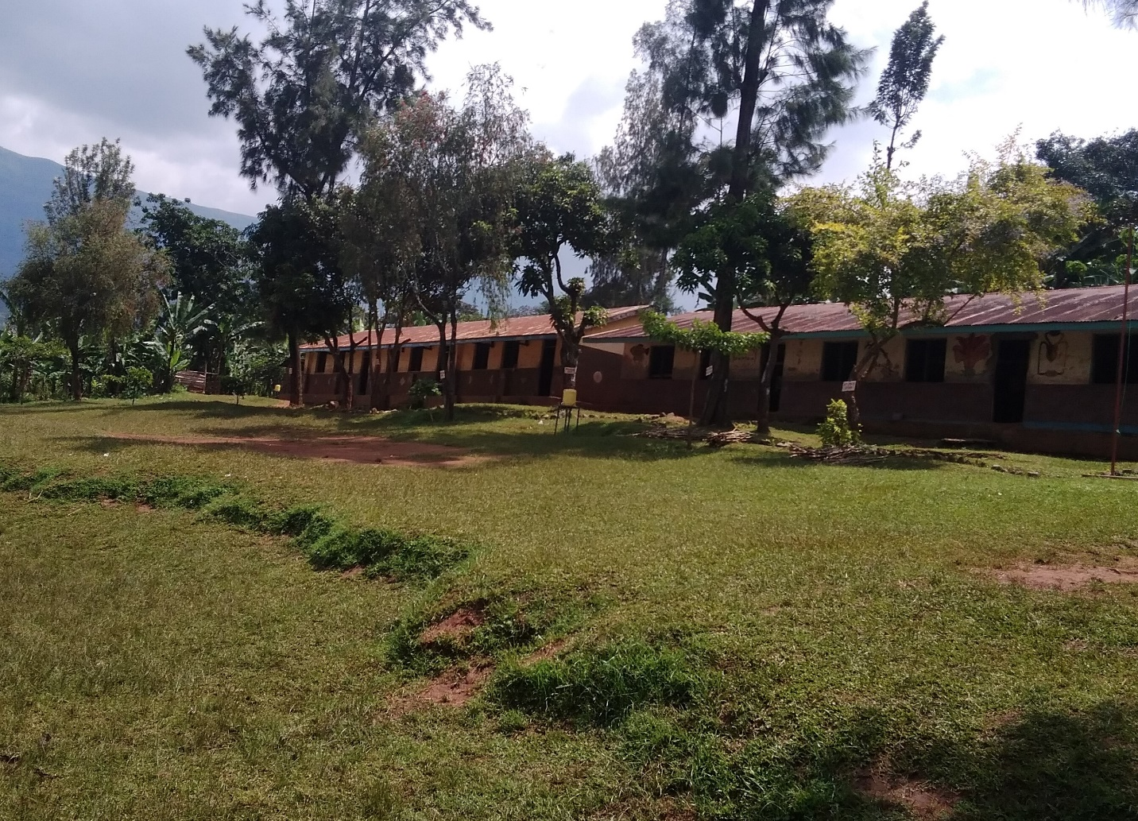Figure 1. Bulwala Primary School
Activity date: Wednesday, 12th November 2025
Time: 10:00 a.m. – 11:20 a.m. (EAT)
Venue: Bulwala Primary School, Bumasifwa Sub-county, Sironko District
Participants: 108 pupils (61 girls, 47 boys), ages 6–16
Organized by: Foundation for Sustainable Environment (FSE) in partnership with partnership Green Nexus Education (United Kingdom).

1. Session Overview
On a bright Wednesday morning in the scenic hills of Sironko District, the Foundation for Sustainable Environment (FSE) in partnership with Green Nexus Education (United Kingdom) ,conducted online a transformative climate change education session at Bulwala Primary School. A total of 108 children 61 girls (56%), and boys 47(44%) were equipped with foundational knowledge on climate change adaptation, environmental protection, and biodiversity conservation.
Learners participated enthusiastically through discussions, demonstrations, and question and answer segments. The presence of the Community Development Officer (CDO) underscored the alignment of the initiative with district priorities and strengthened government community collaboration.
This was more than a learning session; it marked the official launch of FSE’s School-Based Climate education initiative, setting the stage for building a climate-conscious generation capable of safeguarding Uganda’s fragile ecosystems.

2. Key Achievements
- 108 learners reached. The session exceeded participation expectations, attracting children across multiple classes, with strong gender balance and inclusive involvement of children of ages 6–16.
- High learner engagement. Pupils demonstrated remarkable curiosity asking questions, sharing observations from their communities, and volunteering during interactive segments.
- Contextualized, age-appropriate content. Ms. Nassi, Executive director of Green Nexus Education (UK) facilitated lessons that matched pupils' learning levels, with illustrations, real-life scenarios, and local examples to ensure clarity and relatability.
- Strong institutional support. The Head Teacher, class teachers, and Community Development Officer (CDO) provided active support throughout the session, confirming the school’s readiness to integrate climate education into its routine school curricula activities.
- Successful project launch. This event officially inaugurated FSE’s climate education project in Sironko District, creating momentum for expansion to several other primary schools in the community.

3. Lessons learned
- Girls showed exceptional enthusiasm, reinforcing the need for gender-responsive climate education approaches that empower girls and women as environmental champions.
- School leadership demonstrated strong commitment, indicating high potential for scaling the initiative within and beyond Bumasifwa sub-county.
- Child-centered facilitation methods including storytelling, visuals, and games proved effective in maintaining attention and improving understanding.
- Early exposure to environmental topics stimulates long-term behavioral change and nurtures future environmental leaders

4. Challenges faced
- Unstable internet connectivity, disrupted virtual learning components, affecting planned multimedia demonstrations.
- Low audio quality limited the clarity of digital content for learners especially seated those sited at the back of the class room during the session.
- Small display screen reduced visibility for a large group, especially during interactive digital lessons.
- Complex terminology of some scientific terms required further simplification for younger learners and coming from rural community schools in African setting.

5. Recommendations and next steps
- Invest in larger screens and quality audio systems ensuring all learners clearly see and hear digital content during climate change sessions.
- There is to secure reliable internet connectivity is essential for uninterrupted virtual learning and access to global environmental resources.
- Expand learning venues larger spaces such as school halls, school compound should be utilized to comfortably accommodate growing numbers of learners’ interest to participate in climate change education sessions.
- Introduce monthly climate education sessions, regular, progressive lessons will reinforce climate-smart behaviors, sustain children participation and content perception.
- Allocate more time for Question &Answer, and reflection, this will deepen comprehension and allow learners to relate the lessons to real community experiences. B.Bumasifwa Primary School - Climate change education session report 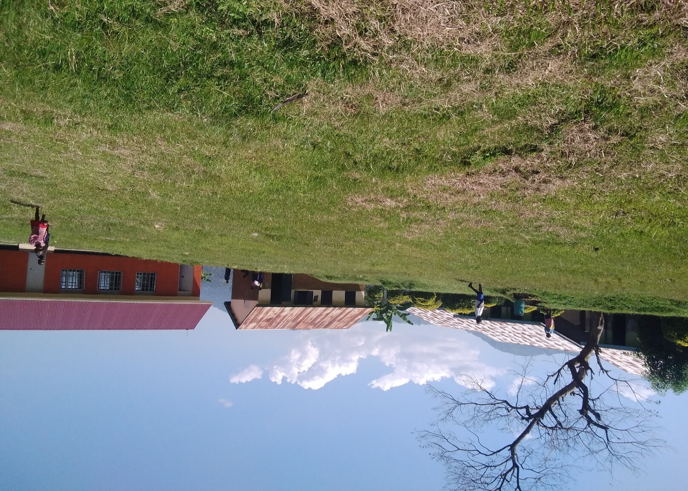Figure 2. Bumasifwa Primary School
Activity date: Thursday, 13th November 2025
Time: 10:00 a.m. – 11:45 a.m. (EAT)
Venue: Bumasifwa Primary School, Legenya Sub-county, Sironko District
Participants: 86 pupils (46 girls, 40 boys), ages 6–16
Facilitator: Ms. Nassi, Executive Director, Green Nexus Education (UK)
Organized by: Organized by Foundation for Sustainable Environment in partnership with Green Nexus Education (UK).

1. Session overview
On Thursday, 13th November 2025, the Foundation for Sustainable Environment (FSE), in partnership with Green Nexus Education (UK), delivered a comprehensive online climate education training to 86 learners at Bumasifwa Primary School. The session engaged 46 girls (53%) and 40 boys (47%), demonstrating strong gender participation and alignment with FSE’s commitment to inclusive, gender-responsive climate programming.
The training introduced pupils to essential concepts of climate change adaptation, environmental stewardship, and biodiversity protection, using videos, visual graphics, and real-life environmental examples. Despite the virtual format, learners remained attentive and actively engaged throughout the session especially during the question-and-answer segment.
Support from the school administration was exceptional. The School Head Teacher and class teachers mobilized attendance, prepared the venue, and provided logistical support, signaling strong ownership and readiness for future project expansion.

2. Key Achievements
- Reached 86 learners aged 6–16 mostly from upper classes. A diverse group of pupils participated, showing attentiveness and curiosity despite the technical nature of the topic.
- Clear and accessible explanations. The facilitator Ms.Nassi of Green Nexus Education (United Kingdom), delivered content in a structured and simple manner, making complex environmental themes understandable to children demonstrating professionalism.
- High-quality visual learning especially videos and graphics projected during the session significantly enhanced comprehension kept learners focused and motivated.
- Strong engagement during Q&A, learners asked thoughtful questions, gave examples of environmental changes in their communities, and eagerly volunteered responses evidence of deep interest and internalization of key concepts.
- Strong institutional support, the school Head teacher and teaching staff demonstrated commitment by mobilizing pupils, preparing the training space, and integrating the session into the school day. This reflects readiness for long-term climate programming affirming partnership with schools.

3. Lessons learned
- Girls demonstrated exceptional participation, especially during the Q&A session, this affirms the need for and value of gender-responsive climate education one of FSE’s strategic priorities.
- The school community expressed readiness and enthusiasm for tree planting, both for environmental conservation and for providing fruit and shade to pupils.
- The existence of ample open space within the school grounds presents a practical opportunity for establishing demonstration gardens, tree planting sites, and outdoor environmental learning areas.
- The success of the session indicates that neighboring schools could be easily mobilized for scaled-up implementation.

4. Challenges observed
- Voice projection issues, the facilitator’s audio was occasionally distorted due to the low-quality or unstable gadgets used at the presenting end.
- Small screen size, the screen used for projecting videos and visuals was too small, limiting visibility for many learners seated behind the class.
- Language barrier, some learners struggled to follow certain terms or dialect used by the facilitator, reducing full comprehension.
- Waterlogged school grounds, the school compound is waterlogged, limiting outdoor play, tree planting spaces, and sometimes affecting learner movement while on school compound.

5. Recommendations and next Steps
- There is need to supply tree seedlings especially fruit and indigenous tree varieties, to support the school’s request for shade trees, improved biodiversity, address water logged compound and supplementary nutrition for pupils.
- There is need for a projector plus a larger display screen, this will enhance visibility for all learners and support ongoing climate education sessions effectively.
- Improve sound systems, a clear audio is essential for virtual learning and will reduce interruptions during future online sessions.
- Provide an interpreter or local language support, simplifying or translating some projected content will increase comprehension, especially for younger learners.
- Ensure access to stable power supply in school, this support projectors, laptops, and online sessions.
- Secure reliable internet connectivity, stable internet will prevent disruptions during virtual training and allow access to global learning materials.
- Expand reach to entire school population as the demand is high, and all children at the school demonstrated this foundational knowledge.
- Provide light refreshments for school mobilizers and activity facilitators, this boosts morale and recognizes their role in mobilizing learners.
- Introduce small incentives for learners like pens, books, and badges, these will motivate children during Q&A sessions and encourage active participation.
- Establish a climate change and environment conservation club in school. A school club will ensure continuity, reinforce daily climate-smart behaviors, and nurture young environmental leaders.

C.Bumasobo Primary School- Climate change education session report

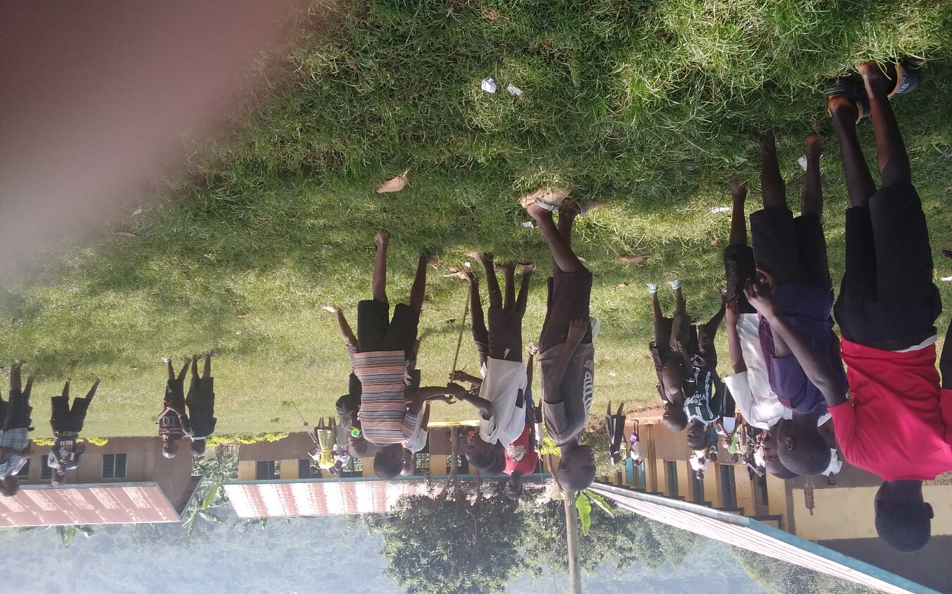Figure 3. Bumasobo Primary School
Activity date: Friday 14th /11/2025
Venue: Bumasobo Primary School, Sironko District
Participants: 124 pupils (67 girls, 57 boys), ages 6–16
Facilitator: Ms Nassi, Executive Director, Green Nexus Education (UK)
Organized by Foundation for Sustainable Environment in partnership with Green Nexus Education (UK).

1. Session overview
The Foundation for Sustainable Environment (FSE), in partnership with Green Nexus Education (UK), conducted an engaging online climate change education session with 124 enthusiastic learners at Bumasobo Primary School. The session involved 67 girls (54%) and 57 boys (46%), reflecting balanced gender representation and strong interest from both groups.
The lesson introduced pupils to climate change adaptation, environmental stewardship, and biodiversity conservation, using interactive videos, real-life examples, and child-friendly explanations. Learners remained highly attentive throughout the training, expressing excitement at being part of an online learning experience a first for many of them. This session strengthened the foundation for establishing long-term climate literacy among children in the region and showcased the school’s readiness and enthusiasm for deeper environmental programming.

2. Key Achievements
- 124 learners reached of ages 6–16, the training successfully engaged a large group of pupils across different class levels, making it one of the highest-attended sessions in the pilot phase.
- Content aligned with the school curriculum, this was evidenced by teachers and pupils appreciated the training because climate and environmental topics align closely with Uganda’s curriculum, increasing relevance and ease of integration into school activities and daily lessons.
- High learner engagement, during the Q&A session, learners demonstrated deep understanding and curiosity asking questions, giving examples, and relating content to their real-life environment.
- Clear visual graphics, the videos used contained attractive visuals that made complex climate concepts easy for children to understand.
- Good use of English language, learners comfortably followed the facilitator’s language, making comprehension smoother than in some other schools where dialect differences posed challenges.

3. Lessons learned
- The school has adequate space suitable for establishing tree nurseries, school gardens, and demonstration eco-zones making it a strong candidate for future greening projects.
- Pupils expressed great excitement about online learning, showing readiness for technology-based environmental education.
- Teachers showed interest in participating in future sessions to better integrate climate content into lessons, which enhances sustainability.
- Some children were observed struggling to get grips on the session through the class widows. This further demonstrates learners interest in climate change education session.

4. Challenges observed
Despite the success of the session, several technical and logistical challenges were identified as follows.

• Audio disruptions, the facilitator’s voice was occasionally interrupted due to gadget malfunction or unstable connections on the presenter’s side.

• Poor video quality, some of the visuals appeared dark, making it difficult for learners to fully interpret the projected information.

• Insufficient sound output, learners seated at the back struggled to clearly hear the ongoing session.

• Small projection screen, with 124 learners in attendance, the screen used for projection was too small, affecting visibility, especially during detailed graphics and illustrations.

5. Recommendations and next steps

1. There is need a loud speaker and improved audio system to ensure clear sound projection for all learners during virtual sessions.

2. Improve visual quality of presentations as learners expressed a desire to clearly see the presenter and improve video clarity for better understanding.

3. There is need to supply tree seedlings especially fruit and shade trees as the school indicated desire and is eager to plant trees within the compound to enhance environmental protection, beautification, shade, and fruit provision.

4. There is need for a larger screen and projector to project clearer and larger graphics suitable for big groups of learners.

5. There is need for interpretation support where necessary the fact that some technical terms need translation or simplification to enhance comprehension for younger pupils.

6. Expand learning space, a larger venue is needed to comfortably accommodate more learners, especially as interest continues to grow.

7. Engage teachers in all sessions to enable them to integrate climate change messaging into the curriculum and sustain learning beyond the project visits.

8. Conduct monthly climate education sessions, routine engagements will reinforce knowledge, stimulate long-term behavior change, and nurture young environmental stewards.

9. Explore community-level engagement, equally parents and community members should receive climate awareness sessions, as requested by the school, to build a holistic climate-resilient community

Conclusion and call to action
This initiative has revealed a powerful truth, Uganda’s rural children are hungry for environmental knowledge and ready to lead the charge against climate change. The excitement, curiosity, and determination witnessed beginning at Bulwala Primary School and echoed across every participating school show that when children are empowered with the right information, they become catalysts for lasting change. Climate action begins with education, and education begins with opportunity.
Foundation for Sustainable Environment (FSE) is committed to scaling this transformative school-based climate education program to all primary and secondary schools in Bumasifwa, Legenya, Bugitimwa sub-counties and Gasawa Town Council, and eventually across Sironko District. This vision can only be achieved through strong partnerships, shared commitment, and sustained investment.
We therefore call upon development partners, government agencies, and friends of the environment to join us in expanding this impactful initiative. Together, we can build a generation that not only understands the climate crisis but is equipped to solve it.
Together, we can ensure that Uganda’s young minds grow not as bystanders, but as protectors of their environment turning classrooms into hubs of hope, innovation, and green leadership.
When we nurture children’s knowledge, we secure the planet’s future.
Prepared by:
Charles Wanziima Samuel
Executive Director, Foundation for Sustainable Environment (FSE)
Contact: +256 774 453 986
Email: wanzimac@gmail.com

Appendix
Bellow: Charles Wanziima Samuel, Executive Director of Foundation for Sustainable Environment facilitating Q& A session. This was shortly after online session presentation Ms. Nassi Green Nexus Education (UK). 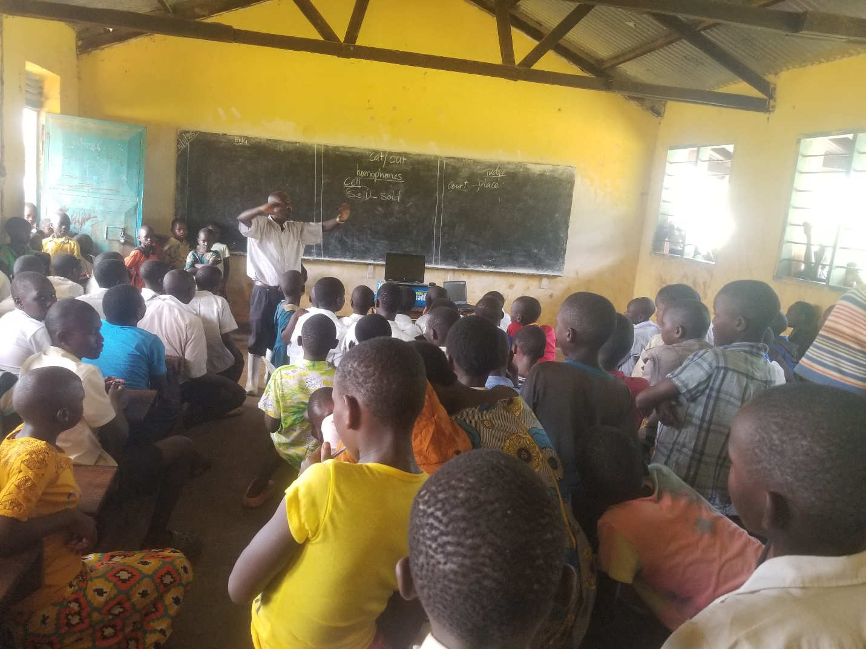Figure 4.Bumasobo Primary School
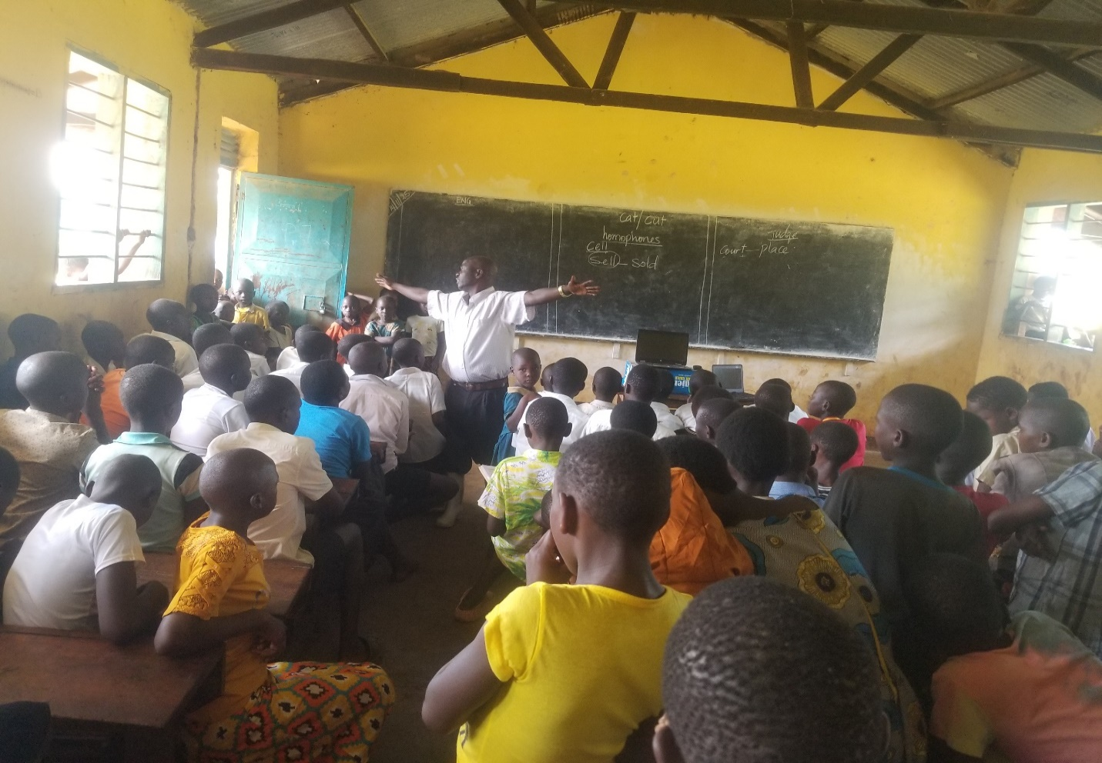
Figure 5.Bumasobo Primary School

Bellow: School pupils had to struggle through the school widows to have a grasp of the online sessions delivered by Ms. Nassi Green Nexus Education (UK).
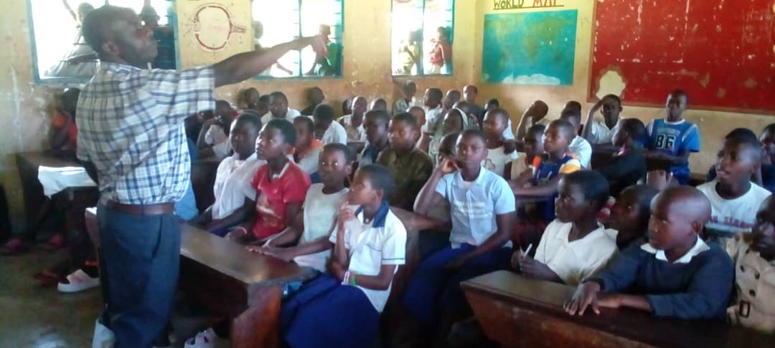
Figure 6.Bumasifwa Primary school

Bellow: School children attentively following online session delivered by Ms. Nassi Executive Director for Green Nexus Education (UK). 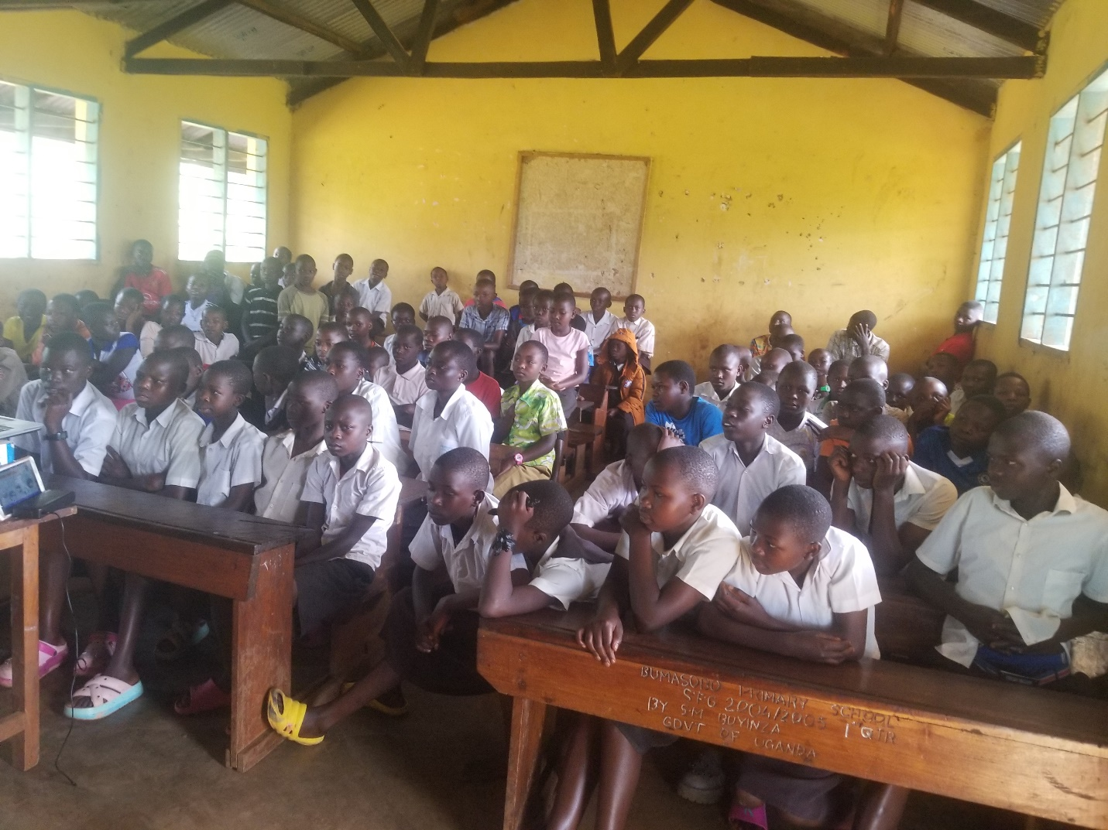Figure 7.Bumasobo Primary School

Bellow: The session was very interesting attracting teacher as well (standing behind the class)
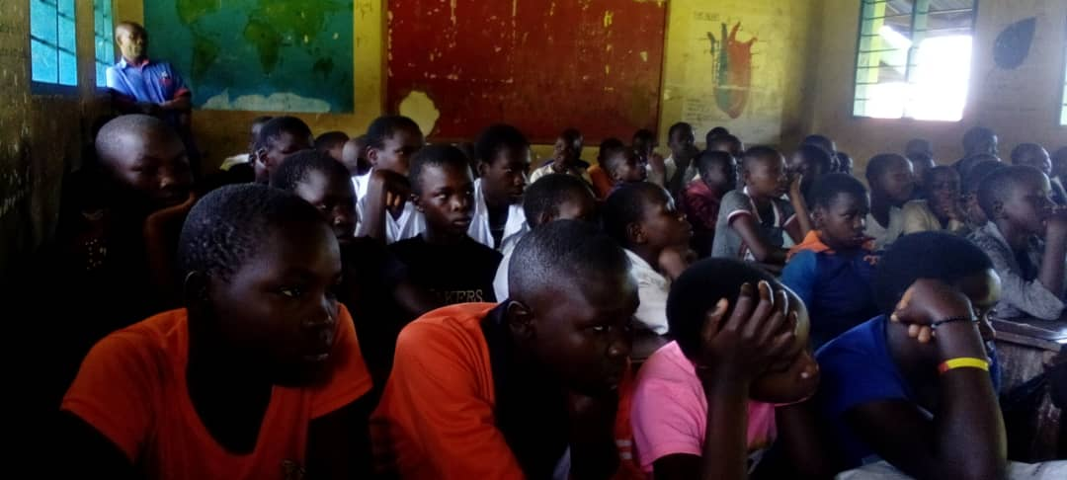
Figure 8. Bumasifwa Primary School

Bellow. Online session going on in Bumasobo Primary school.
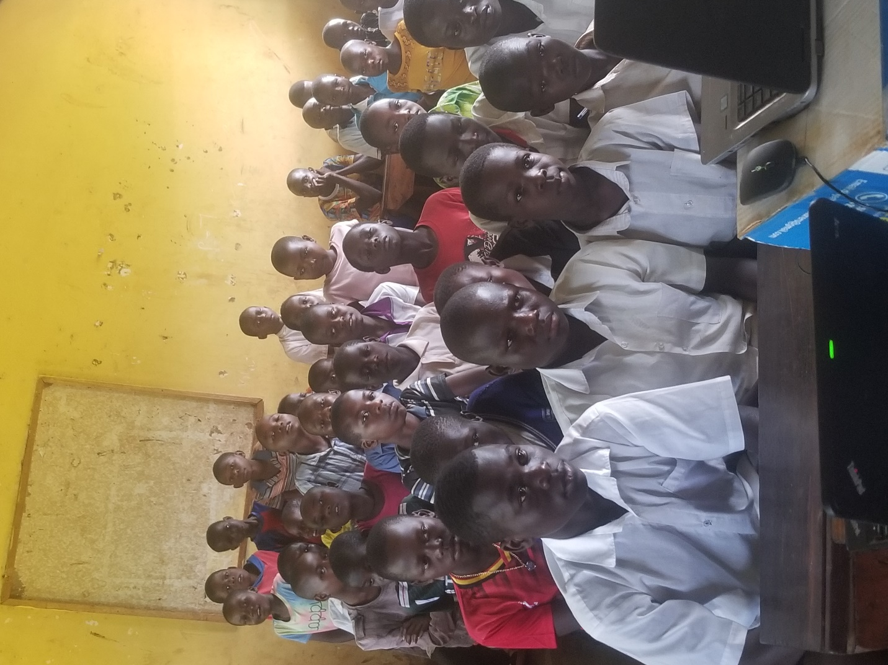
Figure 9. Bumasobo Primary School

Bellow: Charles Wanziima Samuel, Executive Director for Foundation for Sustainable Environment inspecting a school compared for future tree planting and fruits activities as part of a wider Climate change Education project. 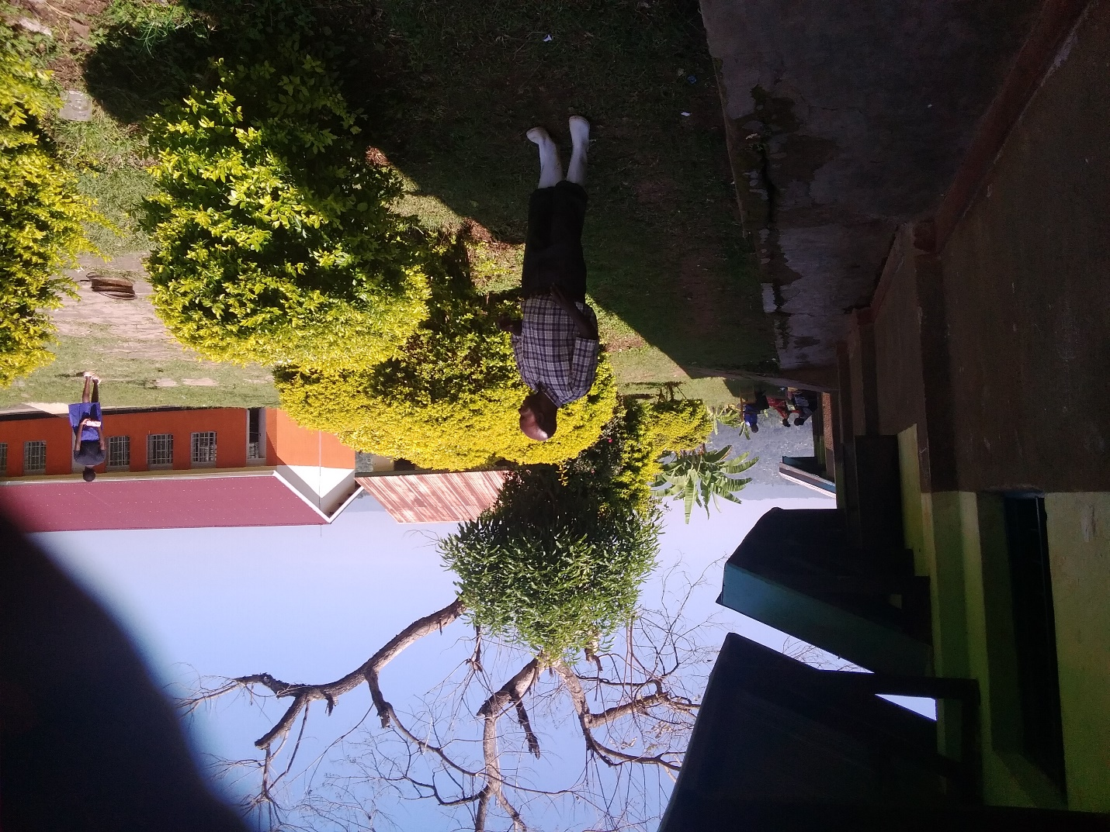
Figure 10.Bumasifwa Primary School

Bellow: Online climate change education going delivered Nassi, Executive Director for Green Nexus Education (UK). As Charles Wanziima Samuel Executive Director closely watching and guiding to ensure smooth and succesful online session. 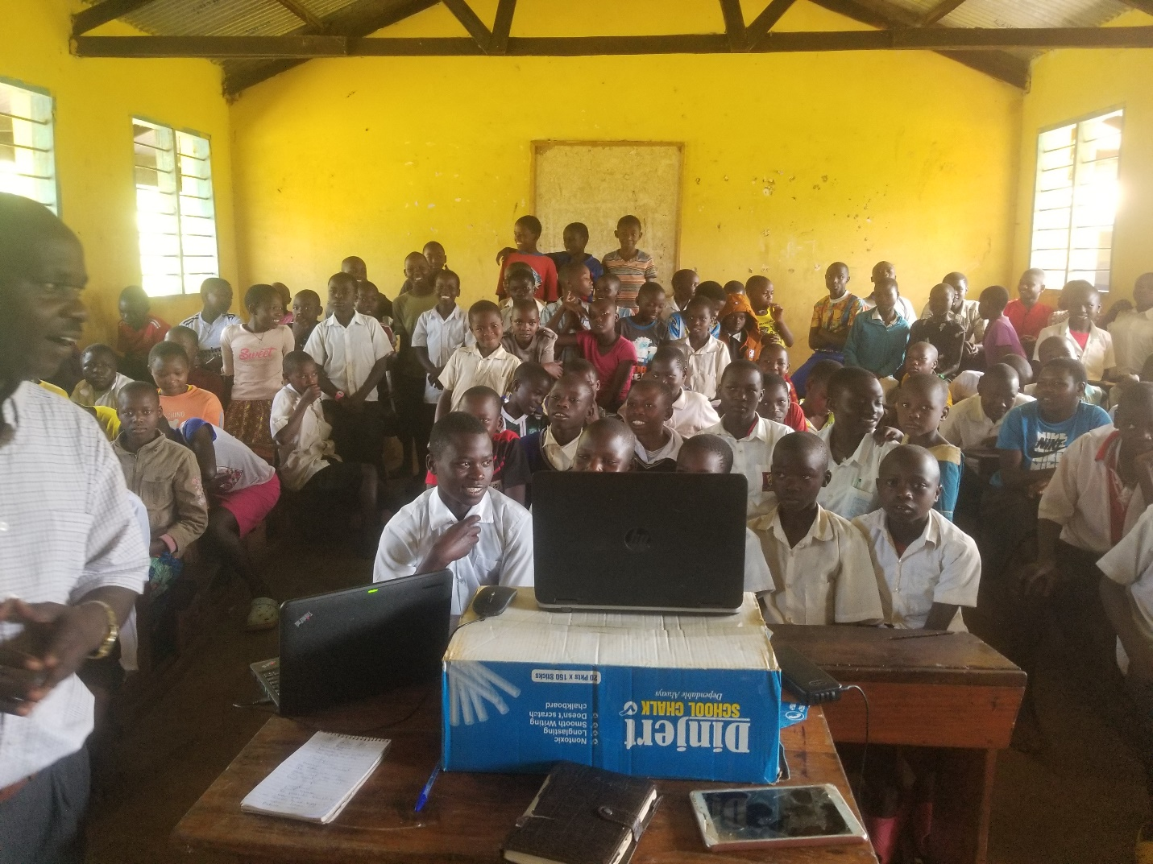
Figure 11.Bumasobo Primary School

Figure 12.Bumasobo primary School

Bellow. Online session going on day one, delivered by Ms.Nassi, Executive Director for Green Nexus Education (UK). (UK).
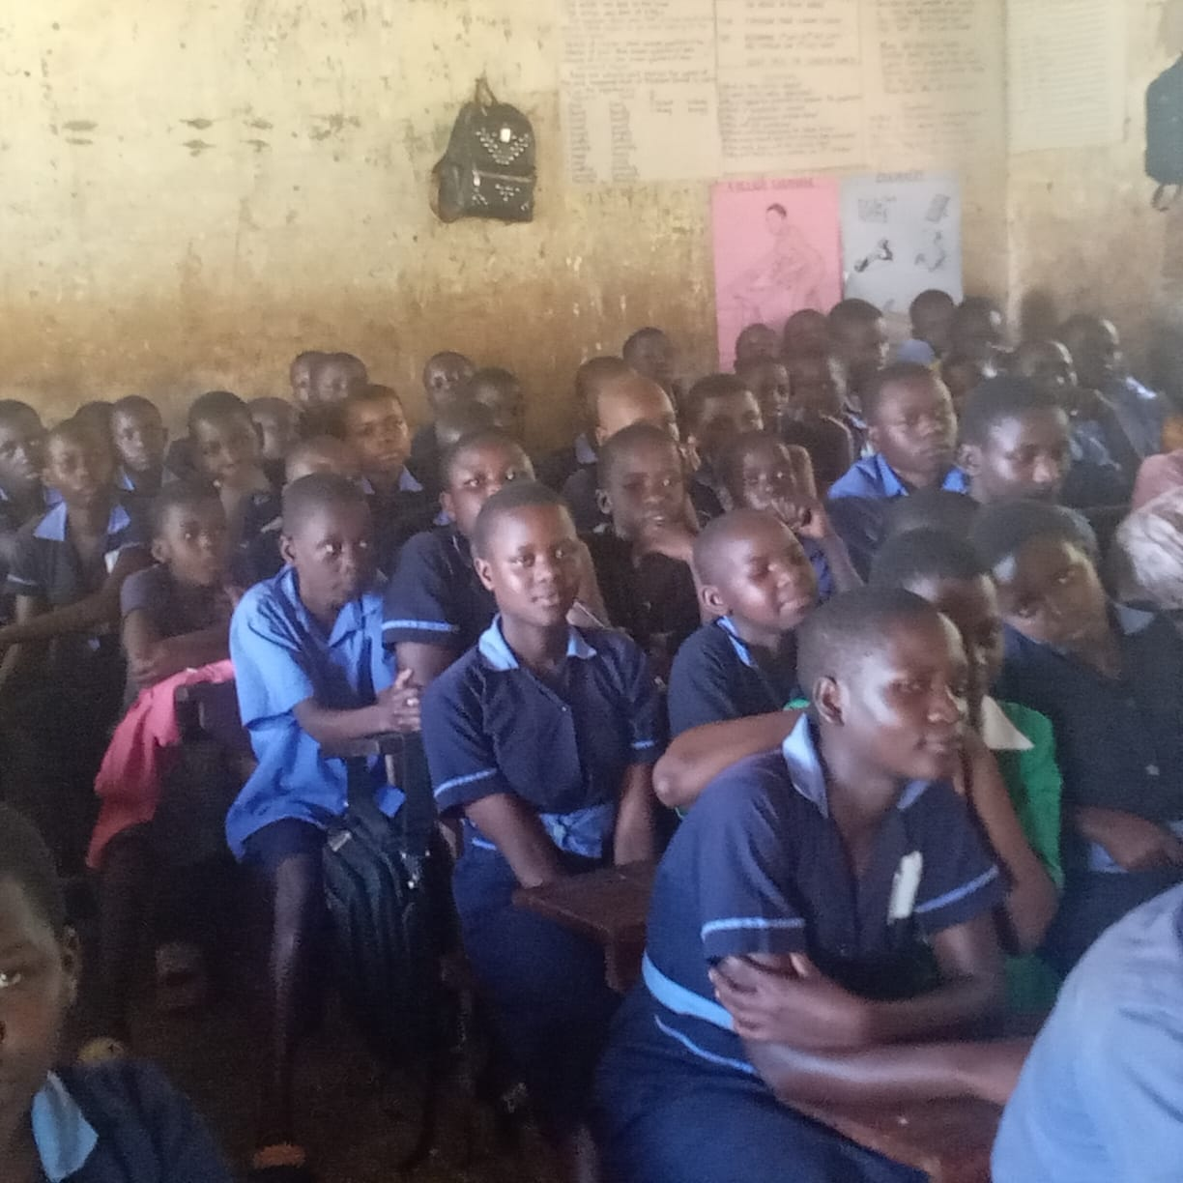
Figure 13.Bulwala Primary School

Bellow: Charles Wanziima Samuel setting, gadgets and equipment for online climate change session delivered Nassi, Executive Director for Green (UK)
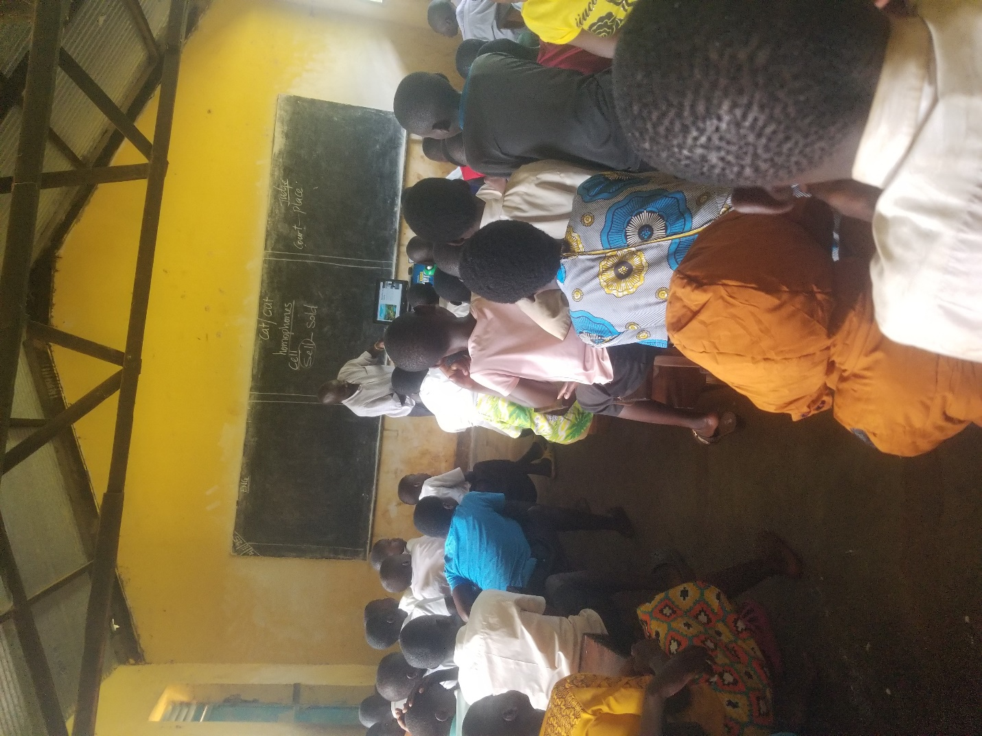
Figure 14.Bumasobo Primary School

